Attendees:
Aimee MacCallum Jennifer Parsonage Shannon McCormick
Andrea Bell Laurel Bridger Sharon Wilson
Betty Soanes Leanne Wyman Tiffany Herrick
Crystelle Ong Lisa Acorn
Erica Yip Lorinda Stuber
Fred Cundict Maureen Buchanan-Chell
Gord Platt Michelle Zwicker Jonathan Suzanski Sara Gallinger

 |  |  | NOTES | PRESENTER | MINUTES
Education: 13:30-14:00 |  |  | CIC Recertification by Continuing Education | Presenting:  Fred Cundict | Fred presented the process of attaining credits for CIC recertification. Leanne Wyman and Lisa Acorn shared their experience. IPAC and the certification board very helpful. Highlighting the benefits of being an executive member.
Business called to order 14:02 |  |  |  | Chair: Maureen
Meeting recorded
1.0 | Welcome & Introductions |  | First Meetings |  | No new attendees
2.0 | Approval of the Agenda |  |  | Chair/All | Motion to approve: Tiffany Herrick Second: Michelle Zwicker Motion approved by consensus.
3.0 | Approval of the Minutes |  |  | Chair/All | Motion to Accept: Sharon Wilson Second: Tiffany Herrick Approved by consensus
4.0 | Membership profile: |  | Aimee MacCallum |  | Thanks Aimee!
5.0 | - New Business
 | 5.1 | Nominations for Executive Positions for 2022-2023 | President-elect  Secretary  Education Chair  Webmaster | Jennifer Parsonage | Maureen presented power point, described the duties of each position, generally 2-year positions. Would like to vote at the November meeting.  IPAC NA need nominations for:  President Elect/Secretary /Education
6.0 | Ongoing Business
 | 6.1 | Education Committee | Topics for next year-submit ideas at meeting or by Oct 31. | Fred Cundict | Fred would like to bring presenters from IPAC conference speakers, IPC Plus speakers. Sara had good ideas.  ? IPAC conference speakers
 | 6.2 | IPC Week | Any Oct 17-21, 2022 Spread Prevention- not Infection  National Infection Control Week | IPAC Canada (ipac-canada.org) | Maureen
 | 6.3 | Strategic Planning | Updates | Jennifer | Yvette, Fred and Jennifer are working on Strategic Planning
Parking Lot Items |  | IPAC NA and SA Collaboration | Deferred
7.0 | Correspondence & Discussion
 | 7.1 | From IPAC Canada | 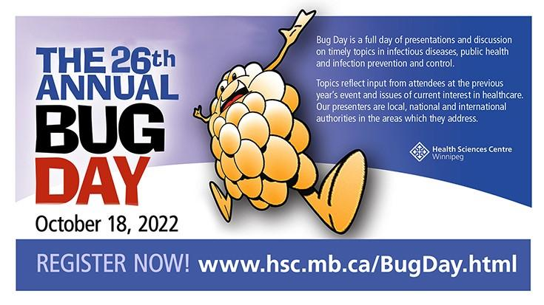  BRING_IN_A_NEW_MEMBER_CONTEST_entry_form_2022.pdf (ipac-canada.org)  IPAC Canada National Conference | IPAC Canada (ipac-canada.org)  UPDATE OF IPAC GUIDELINES – PHAC- Needs assessment questionnaire. Deadline Oct 15. | Maureen
8.0 | Standing IPAC-Canada Interest Groups - Representatives
 | 8.1 | Cardiac Care |  | Michelle Zwicker | Next meeting in December
 | 8.2 | Community Health |  | Kathy Jarema
 | 8.3 | Dialysis |  | Deborah Hobbs
 | 8.4 | Environmental Hygiene |  | Gord Platt
 | 8.5 | Healthcare Facility Design & Construction |  | Laurel Bridger
 | 8.6 | Long-term Care |  | Sara Gallinger | Now active
 | 8.7 | Mental Health |  | Carolyn Doroshuk/  Leanne Wyman | Meetings resurrected
 | 8.8 | Network of Networks |  | Jennifer Parsonage
 | 8.9 | Oncology |  | Aimee MacCallum
 | 8.1.0 | Pediatrics & Neonatal |  | Crystelle Ong | Gave an update meeting to be held next week
 | 8.11 | Pre-hospital & First Responders |  | Vacant
 | 8.12 | Reprocessing |  | Terry Lauriks
 | 8.13 | Surveillance/Applied Epidemiology |  | Kaitlin Hearn
9.0 | Standing IPAC-Canada Internal Committees - News
 | 9.1 | Programs and Projects |  | No IPAC NA rep required
 | 9.2 | Standards and Guidelines |  | Fred Cundict
 | 9.3 | Membership |  | Yvette Gable
 | 9.3 | Chapter Council |  | Dione Kolodka from SA | Position rotates each 2 years between B.C/AB/Sask
Next Meeting |  |  | November 16, 2022 |  | Member profile next meeting: Sukhi Jagpal
Adjournment |  |  | Motion to adjourn: Sara Gallinger at 14:55.

