ATTENDEES
Online Attendance Only | Anna Sandulescu  Betty Soanes  Bonita Lee  Connor Rutherford  Crystelle Daiz  Erica Yip  Fred Cundict | Gord Platt  Kelvin Yu  Jeremy Kerr  Leanne Wyman  Lorinda Stuber  Maureen Buchanan-Chell | Melissa Kobelsky  Raquel Nogueira  Richard Ding  Sandra Dunbar  Yvette Gable  Tiffany Herrick

AGENDA ITEM |  |  | NOTES | PRESENTER | MINUTES
Education Session: 1419 h-1502h |  |  | Published research by AHS peer reviews and conversation TED talk |  | Celeste Headlee – 10 Ways to Have a Better Conversation  Surveillance and Standards have published a number of journal articles that can be found on KRS: krs.libguides.com/IPC  Discussion about research and publications
Call to Order |  |  | 13:32 | Chair – Sara Gallinger
1.0 | Welcome And Introductions |  | - New Executives  New members | Chair | President-elect: Leanne Wyman  Secretary: Kelvin Yu  Education Chair: Suhki Jagpal  Webmaster: Jenn Parsonage  No new attendees
2.0 | Approval Of The Agenda |  |  | Chair/All | Motion to Accept: Fred Cundict, seconded: Maureen Buchanan-Chell. Motion approved by consensus
3.0 | Approval Of The Minutes |  | - November 2022 | Chair/All | Motion to Accept: Leanne Wyman, seconded: Yvette Gable. Motion approved by consensus
4.0 | Member Profile Presentation |  | - What kind of dog are you? | Chair | Fill schedule for 2023  Member profile substituted with fun questions/song
5.0 | New Business
5.1 |  |  | Presidents Update
6.0 | Ongoing Business
6.1 |  | Education Committee | Update  Fall education day? | Suhki | - Planning in progress, will have education in March  - Send us any ideas you may have  - Discussion about Fall Education day; separate from education committee.
6.2 |  | Strategic Planning |  | Fred | - Jennifer P, Yvette, and Fred are working on updating  - Inspire, nurture, and advance  - James Delaney: Deputy Director of World University Service of Canada (WUSC). A non-profit that works to better the world for all young people  - How we can better those less fortunate than ourselves (e.g. donating PPE, volunteering, IPC related, etc.)
Parking Lot Items |  | Deferred | - IPAC NA and SA Collaboration |  | - Will touch base with SA chapter (Kim Houde)
7.0 | Correspondence & Discussion
7.1 |  | From Diversey  From IPAC Canada | 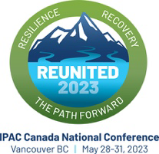  Abstract deadline is 2359h, January 27, 2023. All poster presentations are in-person only, oral presentations can be virtual or in-person.  - 2024: St John’s, NL  - 2025: Winnipeg, MB  - 2026: Toronto, ON | Sara | - Funding opportunities available (e.g. CARNA, AHS)  - Diversey scholarship deadline extended to February 28, 2023  - Free Webinar by Queen’s University about AI in Healthcare: Mon, February 27, 2023 @ 4PM ET. Registration link  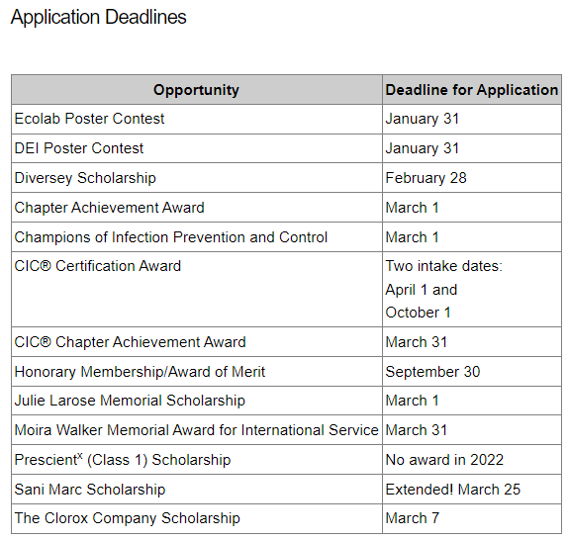
8.0 | Standing IPAC-Canada Interest Groups - Representatives
8.0 |  | Cardiac Care |  | Michelle Zwicker
8.1 |  | Community Health |  | Betty Soanes
8.2 |  | Dialysis |  | Deborah Hobbs
8.3 |  | Environmental Hygiene |  | Gord Platt | - Needs assessment survey was sent out to optimize meetings for this year  - Jan 26 is next meeting. Guest speaker: Anne Bialachowski from St Joseph’s Healthcare Hamilton; topic: Challenge of Providing Feedback
8.4 |  | Healthcare Facility Design & Construction |  | Laurel Bridger | - Next meeting Jan 19  - Potential for discount for CSA courses starting March
8.5 |  | Long-term Care |  | Sara Gallinger | - Surveillance workshop in February 2023  - CSA Z8000 released  - PHAC exploring barriers to antimicrobial stewardship in Canadian LTC facilities
8.6 |  | Mental Health |  | Carolyn Doroshuk
8.7 |  | Oncology and Transplantation |  | Maureen Buchanan-Chell
8.7 |  | Pediatrics & Neonatal |  | Crystelle Daiz
8.8 |  | Pre-hospital & First Responders |  | Vacant
8.9 |  | Reprocessing |  | Terry Lauriks
8.10 |  | Surveillance/ Applied Epidemiology |  | Maureen Buchanan-Chell
9.0 | Standing IPAC-Canada Internal Committees - News
9.1 |  | Programs and Projects |  | No IPAC NA rep needed currently
9.2 |  | Standards and Guidelines |  | Fred Cundict | The standards meeting was short.  Looking to review  -Perioperative Antibiotic Prophylaxis  -Antibacterial Products in the Community  -Electronic Devices  -Healthcare Facility Design PR  Also looking at reviewing the IPAC Program Standards  Lastly discussed adopting an Ethical Framework. That was generally in favor so now reviewing and adopting a template before sharing.
9.3 |  | Membership |  | Kelvin Yu/Sara Gallinger
9.4 |  | Chapter Council |  | Dione Kolodka from IPAC SA | The position rotates each 2 years between B.C/AB/Sask
Next Meeting |  |  | March 8, 2023 @ 13:30
Adjournment |  |  | 14:14 adjournment
Please send your up-to-date contact information (i.e. email) to
Kelvin Yu, Secretary, IPAC-NA
Kelvin.Yu@ahs.ca

